Over the past 24-hours I have received a number of question regarding the following statement “CMS will apply the E/M code changes similar to those that were to be effective in 2021 to all telehealth services provided during the current public health emergency, meaning that telehealth E/M levels can be selected based on Medical Decision Making (MDM) **or** Time (with time defined as all of the time associated with the E/M on the day of the encounter).   To reduce the potential for confusion, CMS is maintaining the current definition of MDM. CMS has also removed any requirements regarding documentation of history and/or physical exam in the medical record for synchronous two-way audio-visual communication telehealth visits.”

**Revisions by AMA and CMS:**

1. **“**Eliminate history and physical as elements for code section: While the physician’s work in capturing the patient’s pertinent history and performing a relevant physical exam contributes to both the time and medical decision making, these elements alone should not determine the appropriate code level.
   * The Workgroup revised the code descriptors to state providers should perform a “medically appropriate history and/or examination”
2. Allow physicians to choose whether their documentation is based on Medical Decision Making (MDM) or Total Time:
   * MDM: The Workgroup did not materially change the three current MDM sub-components, but did provide extensive edits to the elements for code selection and revised/created numerous clarifying definitions in the E/M guidelines. (See below for additional discussion.)
   * Time**:** The definition of time is minimum time, not typical time, and represents total physician/qualified health care professional (QHP) time on the date of service. The use of date-of-service time builds on the movement over the last several years by Medicare to better recognize the work involved in non-face-to-face services like care coordination. These definitions only apply when code selection is primarily based on time and not MDM
3. Modifications to the criteria for MDM**:** The Panel used the current CMS Table of Risk as a foundation for designing the revised required elements for MDM. Current CMS Contractor audit tools were also consulted to minimize disruption in MDM level criteria
   * Removed ambiguous terms (e.g. “mild”) and defined previously ambiguous concepts (e.g. “acute or chronic illness with systemic symptoms”)
   * Also defined important terms, such as “Independent historian”
   * Re-defined the data element to move away from simply adding up tasks to focusing on tasks that affect the management of the patient (e.g. independent interpretation of a test performed by another provider and/or discussion of test interpretation with an external physician/QHP)

Medical decision making (MDM) or total time will be used to make the determination of your level of EM service. Additionally, and as always, medical necessity for the level of service must be identifiable within the documentation. The chart below represents the AMA changes to the titles of the subcategories in the MDM Table (as noted in the table below).

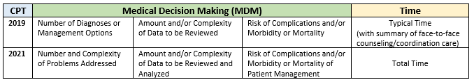

**The following chart provides a comparison of current typical times for office codes and the time ranges for the codes in 2021.**

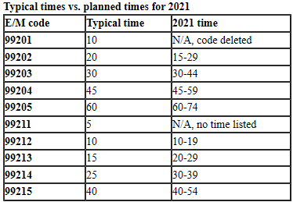 **AMA CHART CMS Timing During Pandemic / Use These**

|  |  |
| --- | --- |
| 99201 | 17 |
| 99202 | 22 |
| 99203 | 29 |
| 99204 | 45 |
| 99205 | 67 |
| 99211 | 7 |
| 99212 | 16 |
| 99213 | 23 |
| 99214 | 40 |
| 99215 | 55 |

**It is the position of DoctorsManagement, that during the COVID-19 Pandemic you utilize the times in the CMS Chart and NOT those of the AMA since CMS does not use a range. CMS has issued contradictory language regarding total times as they have with which aspect of the MDM to follow as you will see in the following language as provided on pg. 136 of the link below**, *“On an interim basis, we are revising our policy to specify that the office/outpatient E/M level selection for these services when furnished via telehealth can be based on MDM or time, with time defined as all of the time associated with the E/M on the day of the encounter; and to remove any requirements regarding documentation of history and/or physical exam in the medical record. This policy is similar to the policy that will apply to all office/outpatient E/Ms beginning in 2021 under policies finalized in the CY 2020 PFS final rule. It remains our expectation that practitioners will document E/M visits as necessary to ensure quality and continuity of care. To reduce the potential for confusion, we are maintaining the current definition of MDM****. We note that currently there are typical times associated with the office/outpatient E/Ms, and we are finalizing those times as what should be met for purposes of level selection. The typical times associated with the office/outpatient E/Ms are available as a public use file at***[*https://www.cms.gov/Medicare/Medicare-Fee-for-ServicePayment/PhysicianFeeSched/PFS-Federal-Regulation-Notices-Items/CMS-1715-F*](https://www.cms.gov/Medicare/Medicare-Fee-for-ServicePayment/PhysicianFeeSched/PFS-Federal-Regulation-Notices-Items/CMS-1715-F)*. This policy only applies to office/outpatient visits furnished via Medicare telehealth, and only during the PHE for the COVID-19 pandemic.***” The problem with the above guidance is that the “Typical Times” do not match the “Actual Times” in the chart in the excel document.** *When you click on the link above scroll down to the zip file “Final Rule Physician Time” or click this link (*[*CY 2020 PFS Final Rule Physician Time (ZIP)*](https://www.cms.gov/Medicare/Medicare-Fee-for-Service-Payment/PhysicianFeeSched/Downloads/CY2020-PFS-FR-Physician-Time.zip)*) then scroll down to the 99201-99215 codes…*

**Use the charts and examples below to select your MDM and the chart above “Typical Times” to select your EM Service for New or Established patients. For other EM Code ranges requiring time, refer to your 2020 CPT Code Manual.**

**Medical Decision-Making (MDM) Table**

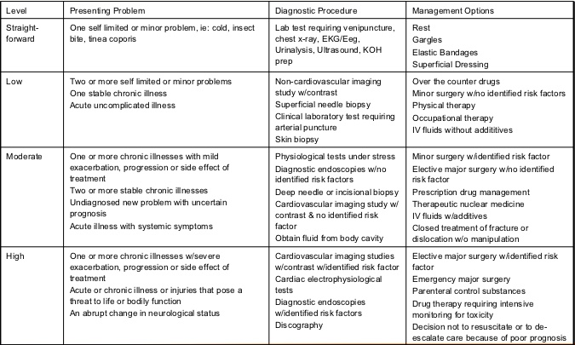

**The chart below is used to determine your overall level of MDM. 2/3 at the lowest level determines your overall level:**

1. Example: One or more chronic illness with mild exacerbation, progression or side effect of treatment and Prescription drug management = Moderate Complexity
2. Example: Abrupt change in neurological status and Prescription drug management = Moderate Complexity
3. Two of more self-limited or minor problems and Over the counter drugs = Low Complexity

**For the chart below, place an “X” in the column furthest to the right for your highest element of MDM and then place your remaining “X(s)” in the box(s) to the left. For example, if you have an element in high, one in moderate and one in low your overall MDM would be Moderate. If you have one in Moderate, one in low and one in straightforward then your MDM would be low.**

